|  |  |
| --- | --- |
| **State Transition Diagrams** | |
| **Project Name:** | **FINALyze – Business Financial Analyzer** |
| **Description:** | The web application calculates the Gross margin, Net margin and ROI for products.  This app provides insight into products Finance health and helps in Analysing its investment decision. |
| **Deadline:** | 29th March 2025 |
| **Student Name:** | Mohammed Aiman Khan |

**USER STORY 1:**

**Title**: User Registration Process

**As a** new user,  
**I want** to register for an account,  
**So that** I can access the FINALyzer platform and get Business performance insight.

**Acceptance Criteria:**

1. The registration form should ask for the following details:
   * User name
   * Email address (with validation for uniqueness)
   * Password (with validation for strength)
   * Confirm password (with validation for checking same password and confirm password)
2. Once the user fills in the required fields, the user should be able to submit the form.
3. If the form data is valid then user is automatically logged in and taken to the home page
4. If there is any error in the form (e.g., invalid email, mismatched passwords), the system will take back to the Registration entry screen.

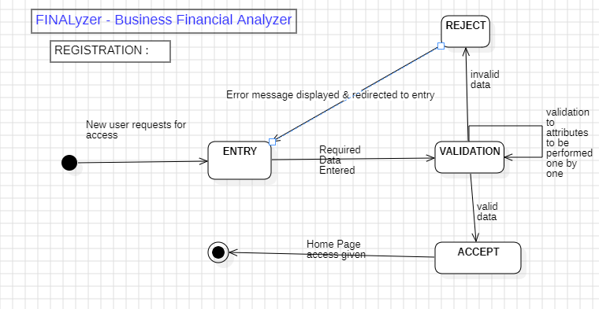

**States:**

1. WAITING: The system remains in a ***WAITING*** state until new user’s request is received.
2. ENTRY: Access the Registration Process, the system goes into ***ENTRY*** state
3. VALIDATION: New user enters the required data and press the submit button, the system goes into ***VALIDATION*** state
4. REJECT: Validation for email, password or confirm password fails, the system moves to ***REJECTION*** state and directs back to ENTRY state
5. ACCEPT: Validation for email, password or confirm password fails, the system moves to ***ACCEPTENCE*** state temporarily and moves to the ***SUCCESS*** state.

**Transitions:**

1. WAITING 🡪 ENTRY
2. ENTRY 🡪 VALIDATION
3. VALIDATION 🡪 REJECTION 🡪 ENTRY
4. VALIDATION 🡪 ACCEPTANCE 🡪SUCCESS